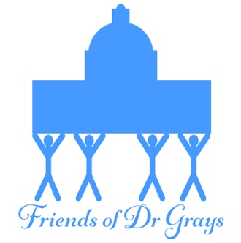
FRIENDS OF DR GRAY’S
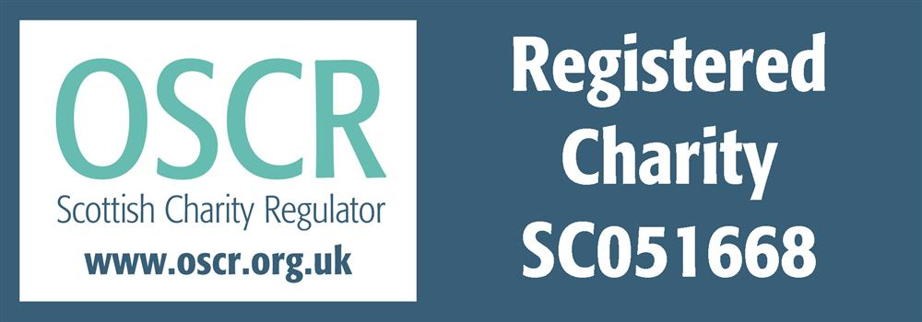
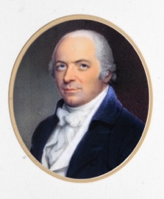
GRAYS 50/50

- Grays 50/50 is a lottery run by the charity “Friends of Dr Gray’s” (FODG) in Elgin.
- Eligibility:
Players must be at least 18 years old.
Members of FODG Committee are excluded from taking part.
- Tickets are issued for a calendar year. The cost for a full 12-month ticket – 12 draws - is £24.00. For tickets bought during the calendar year the cost is reduced pro-rata, i.e., a ticket bought in April for the remaining 8 draws costs £16.00. It is possible to purchase more than one ticket per person. Each month there is a single prize, 50% of the contributions for the previous month.
- For example:
If a total of 153 ticket numbers are issued by the cut-off date in May, the total amount taken for the following month is £306.00. Half of this, £153.00, will be the prize money for June draw.
- The winning ticket will be drawn at the FODG Committee meetings (normally held on 2nd Thursday of the month). The following table illustrates the ticket prices and the number and the anticipated date of the draws:
Cut-off Date | Cost | Number of draws | Draw  Date
31/12/22 | £24.00 | 12 | 12/01/23
31/01/23 | £22.00 | 11 | 09/02/23
28/02/23 | £20.00 | 10 | 09/03/23
31/03/23 | £18.00 | 9 | 13/04/23
30/04/23 | £16.00 | 8 | 11/05/23
31/05/23 | £14.00 | 7 | 08/06/23
30/06/23 | £12.00 | 6 | 13/07/23
31/07/23 | £10.00 | 5 | 10/08/23
31/08/23 | £8.00 | 4 | 14/09/23
30/09/23 | £6.00 | 3 | 12/10/23
31/10/23 | £4.00 | 2 | 09/11/23
30/11/23 | £2.00 | 1 | 14/12/23

- The winning number will be generated by a Random Number app, and published on our Facebook page.
- Tickets can be paid for by cash, card, bank transfer or cheque. The money, together with the purchaser’s full name and a valid e-mail address, needs to be given or forwarded to the lottery’s secretary, who will issue a ticket number to the purchaser via the e-mail address provided. In compliance with data protection regulations, the lottery’s secretary will not retain any record of the purchaser’s personal data, unless being authorised by the purchaser for the sole purpose of informing the winner after the draw.

Friends of Dr Gray’s Committee December 2022

